Functions (Part 1 Basics)

LAB # 06



Spring 2022

CSE-102L COMPUTER PROGRAMMING LAB

Submitted by: MUHAMMAD SADEEQ

Registration No.: 21PWCSE2028

Section: C

"On my honor, as student of University of Engineering and Technology, I have neither given nor received unauthorized assistance on this academic work.'

Student Signature: _____________________

Submitted to:

Engr. Abdullah Hamid

(July 2022)

Department of Computer Systems Engineering University of Engineering and Technology, Peshawar

# Lab 6: Functions (Part 1 Basics)

## Objectives:

To understand function programming, its types and function-call.

## Tasks:

**Note: Implement all the tasks using functions.**

1. Write a program that takes marks and registration number as input and then displays your name, grade and registration number using function. (You must use your own name and registration number also the grade must be calculated on the bases of marks).
2. Write a function minmax () that takes four integers as input and display the minimum and maximum number.
3. Your program should have a function named ‘prime’ which accepts an integer and return a Boolean (a true if the number is prime and false otherwise). Return type bool function
4. Write a program to find a factorial of user input number. Use function to find factorial.
5. Write a program to find the roots of a quadratic equation of type a.x2+b.x+c where the value of a, b, c is to be entered by the user inside main() and the values must be stored inside an array called values. make sure value of a must be non-zero if it is complete the program. There must be two function one called roots() the other called deter(). First main() will send the array values to deter to calculate d and then send the calculated d to roots() .

**Algorithm for function deter():**

* 1. Read the coefficients of a quadratic equation a, b, c
  2. Calculate determinant d = b*b – 4*a*c
  3. Return d value to main()

**Algorithm for function roots():**

* 1. roots() will receive value of d from main() and then calculate and display the following
  2. If d > 0 calculate two real roots r1 = (-b + sqrt(d)) / (2*a) and r2 = (-b - sqrt(d)) / (2*a)
  3. If d=0, then roots r1 and r2 are equal and display r1 = r2 = -b/(2*a)
  4. If d < 0 then roots are imaginary and display real root= -b/(2*a) and img root =sqrt(-d)/(2*a)

Hint: deter() is return type and roots() is non-return type. The array which will have the values of a, b ,c should be declared globally (before main()) so that it could be accessed by all functions.

**COMPUTER PROGRAMMING LAB # 6**

**Answer #1**

**CODE:**

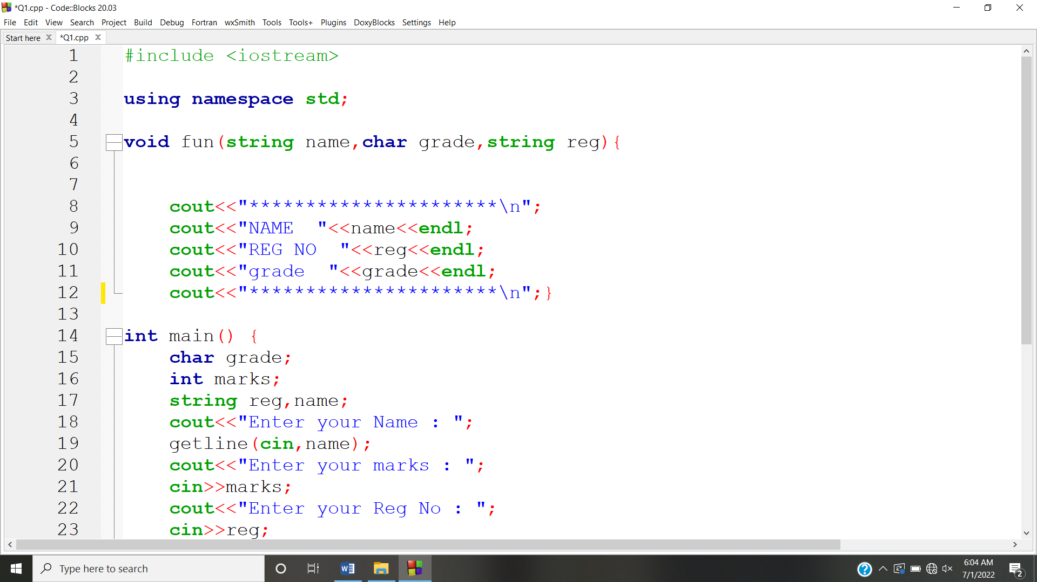

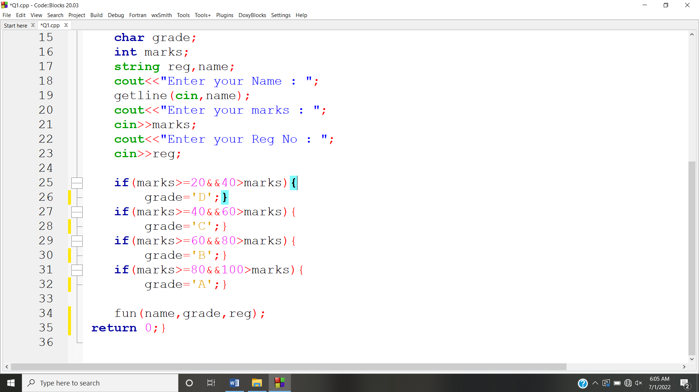

**OUTPUT:**

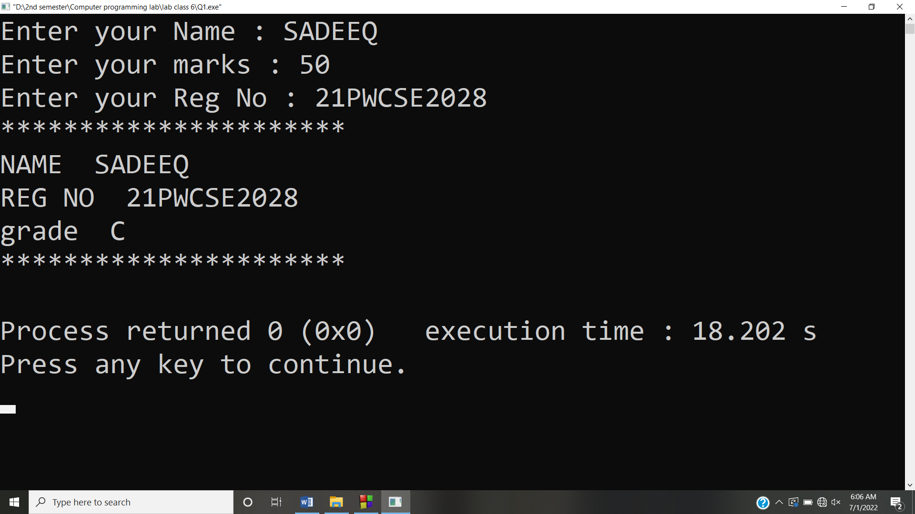

**Answer #2**

**CODE:** 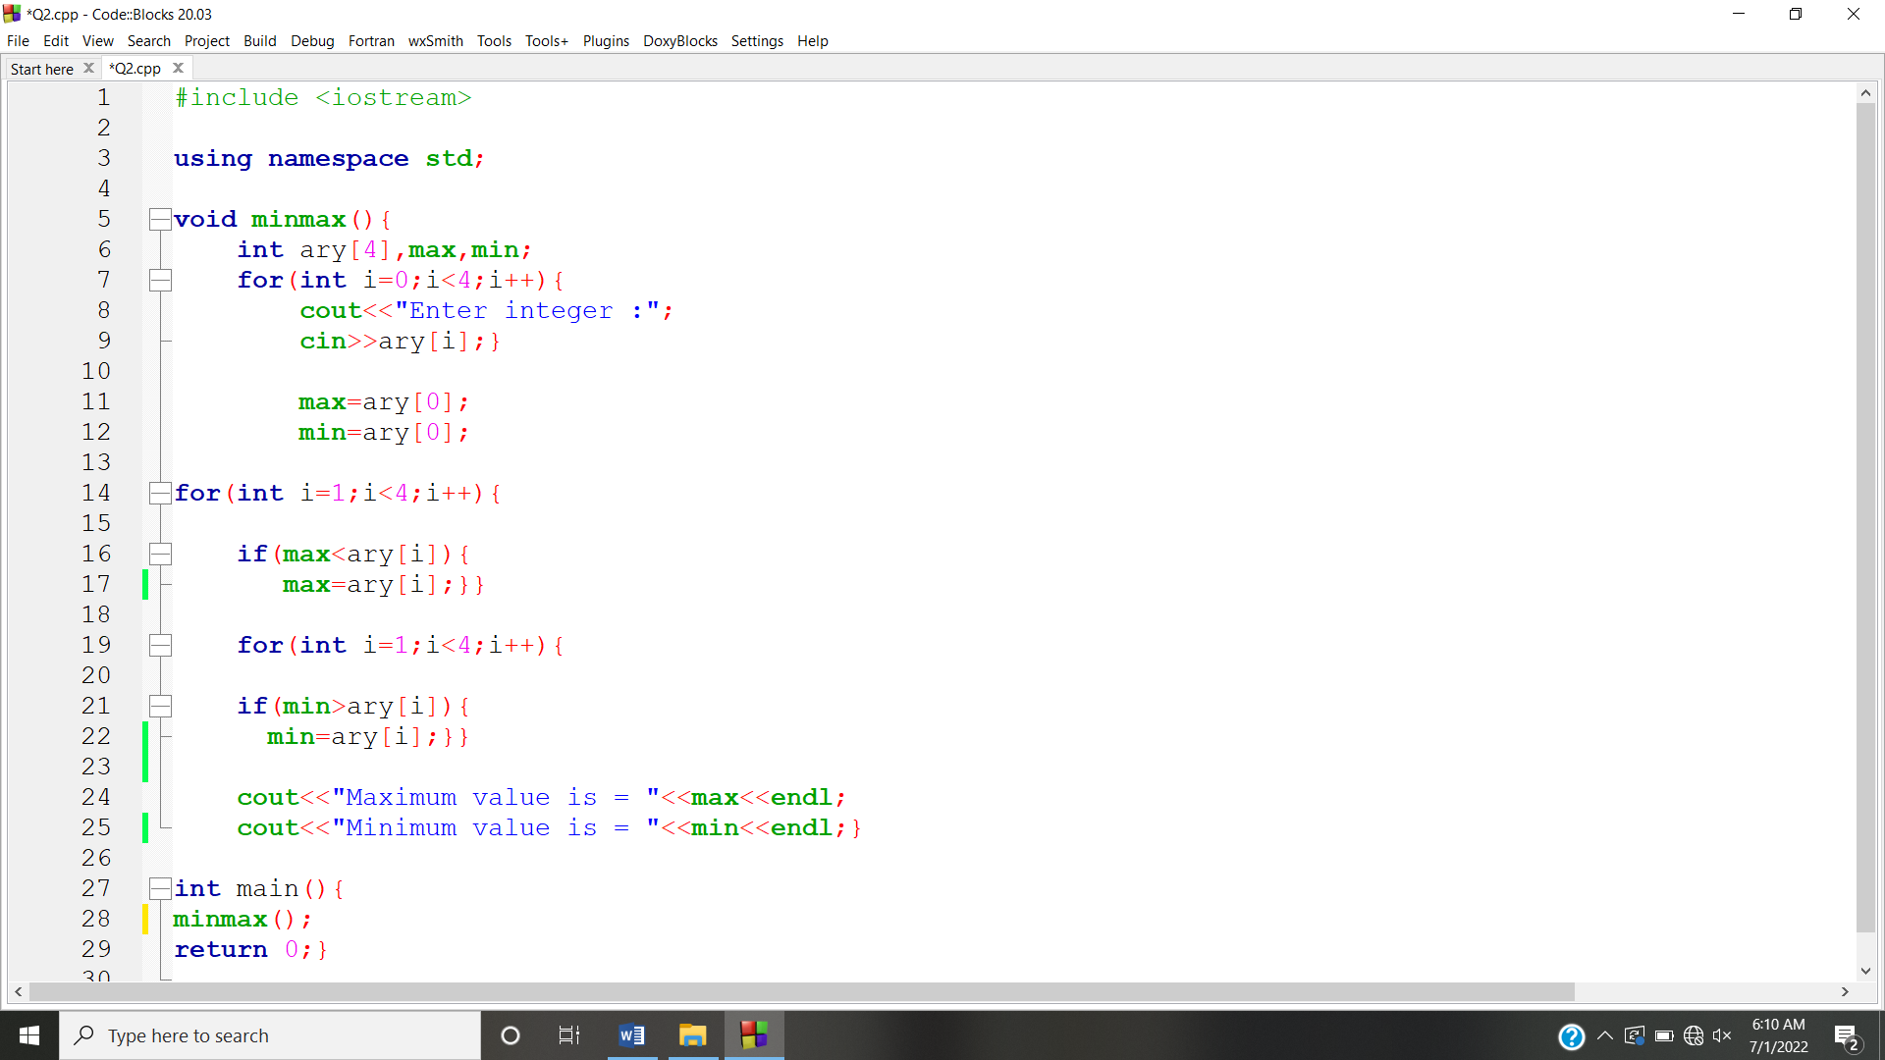

**OUTPUT:** 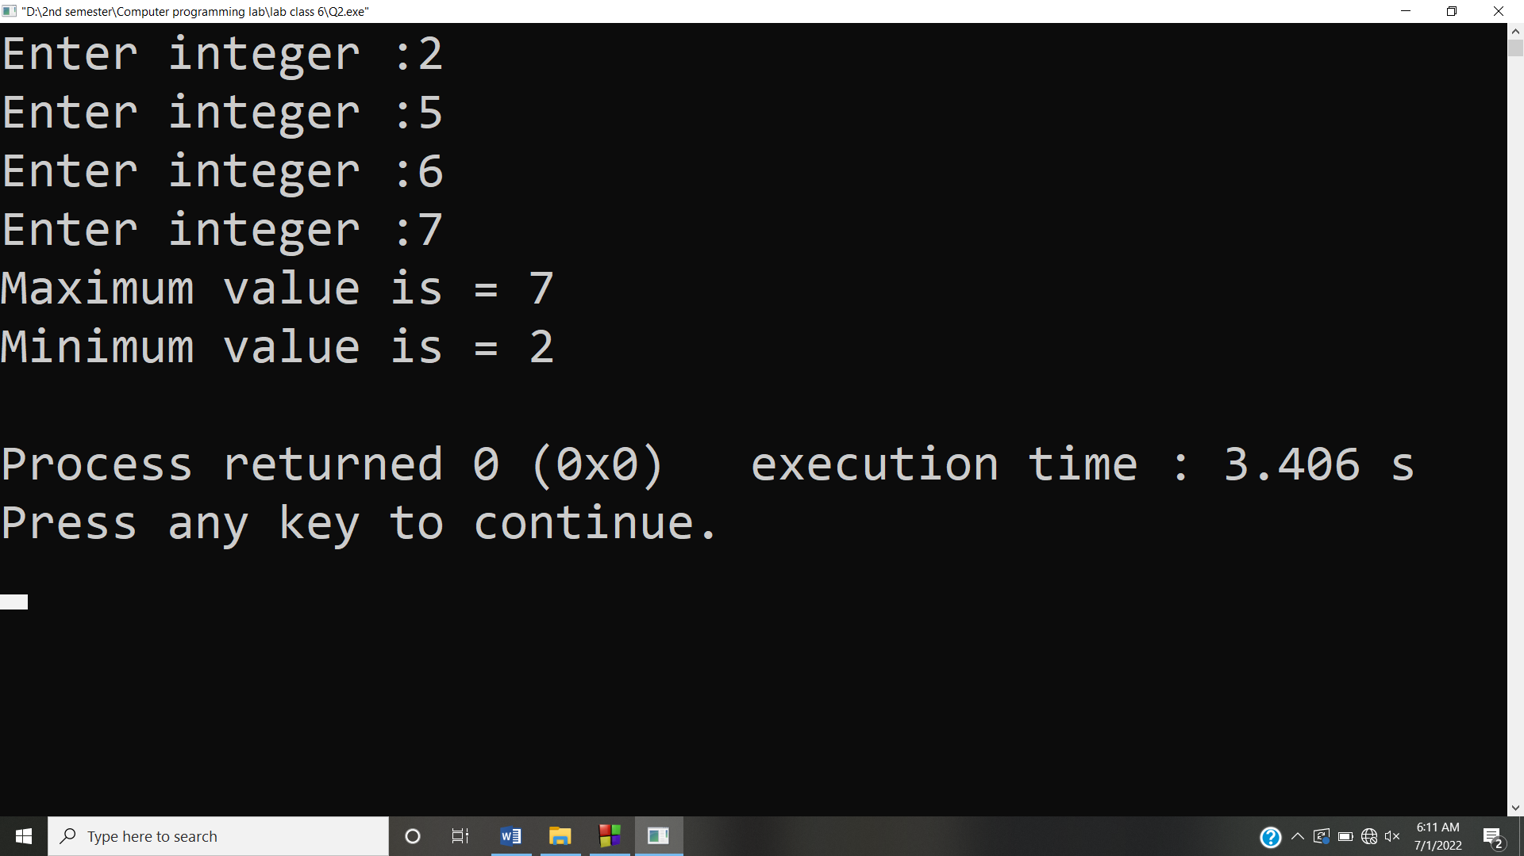

**Answer #3**

**CODE:** 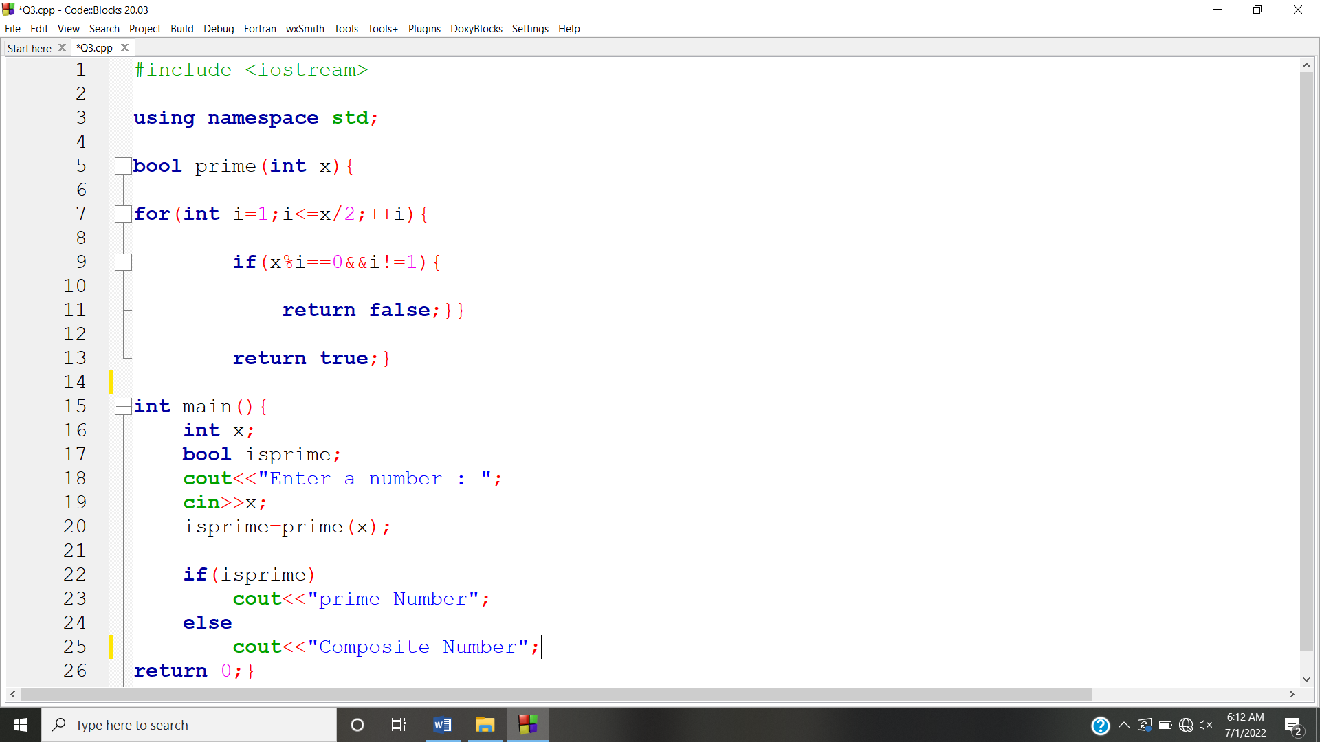

**OUTPUT:** 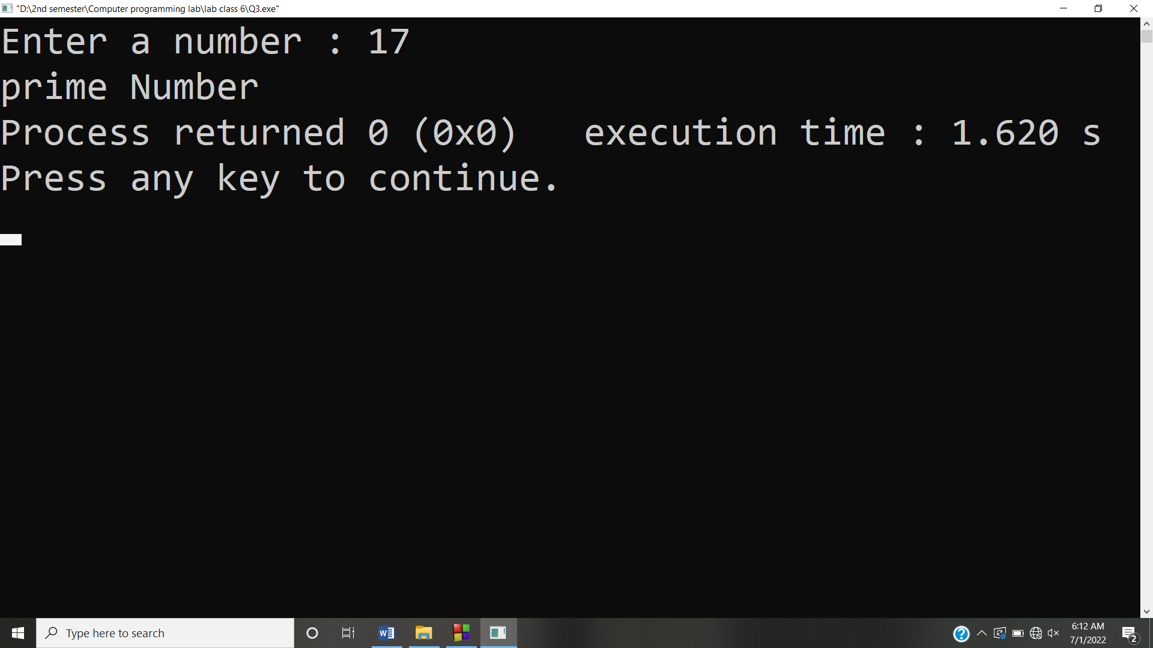

**Answer #4**

**CODE:** 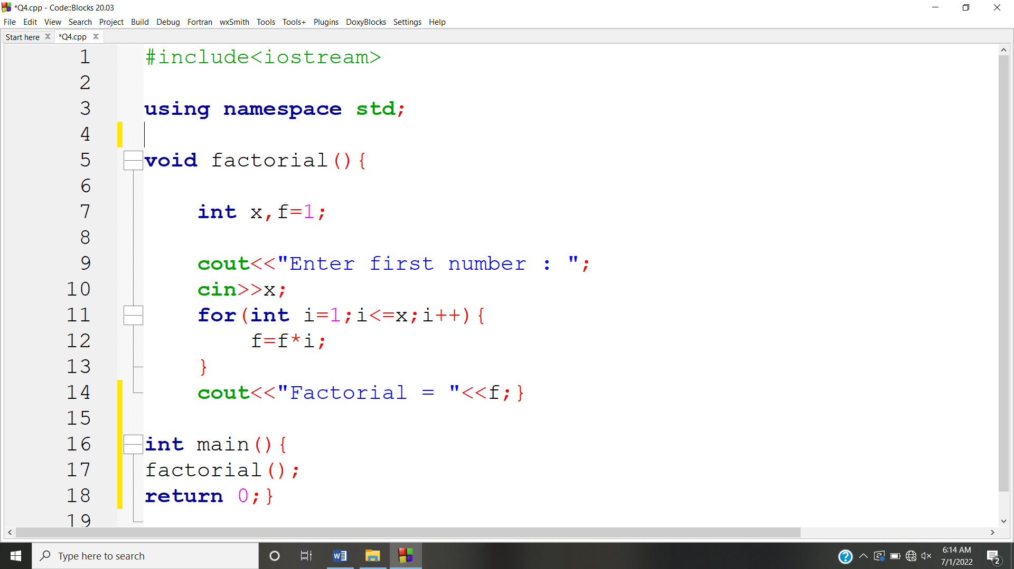

**OUTPUT:** 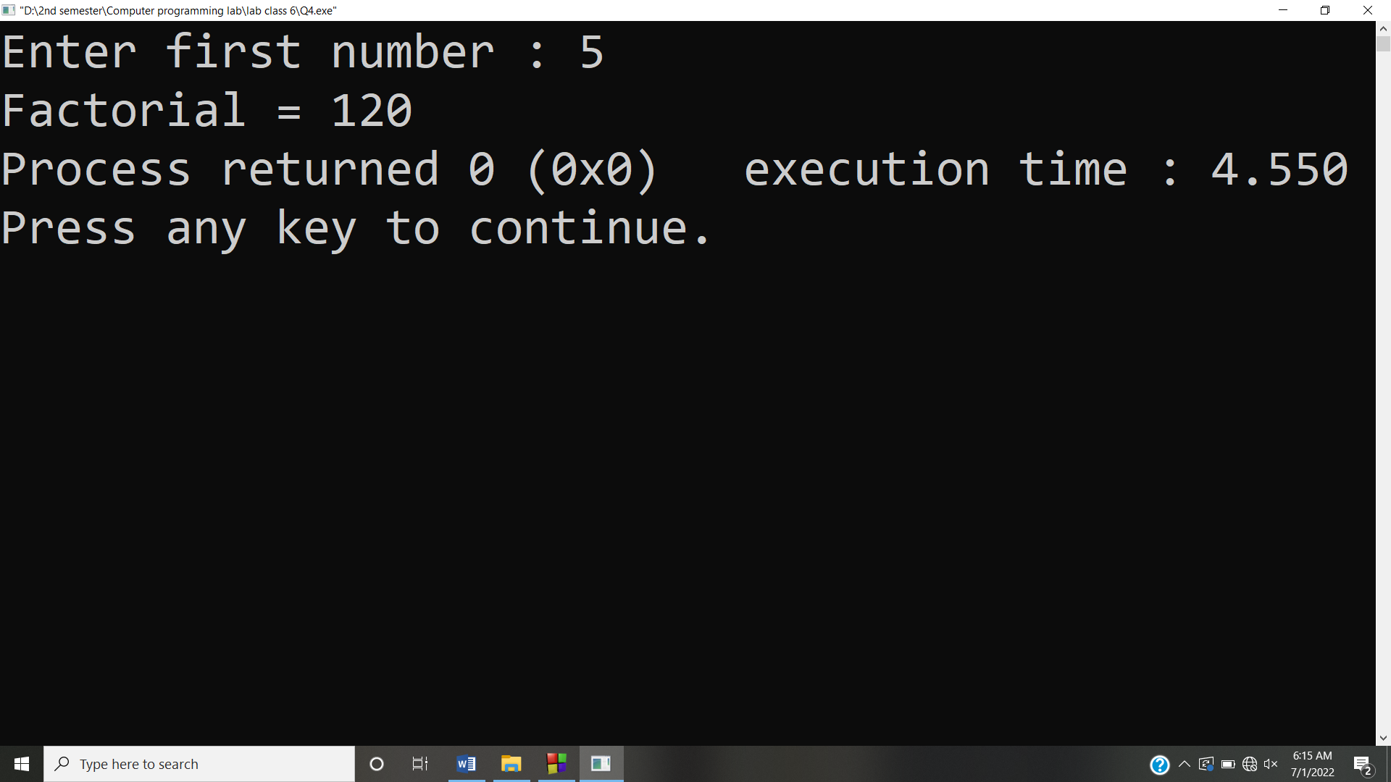

**Answer #5**

**CODE:** 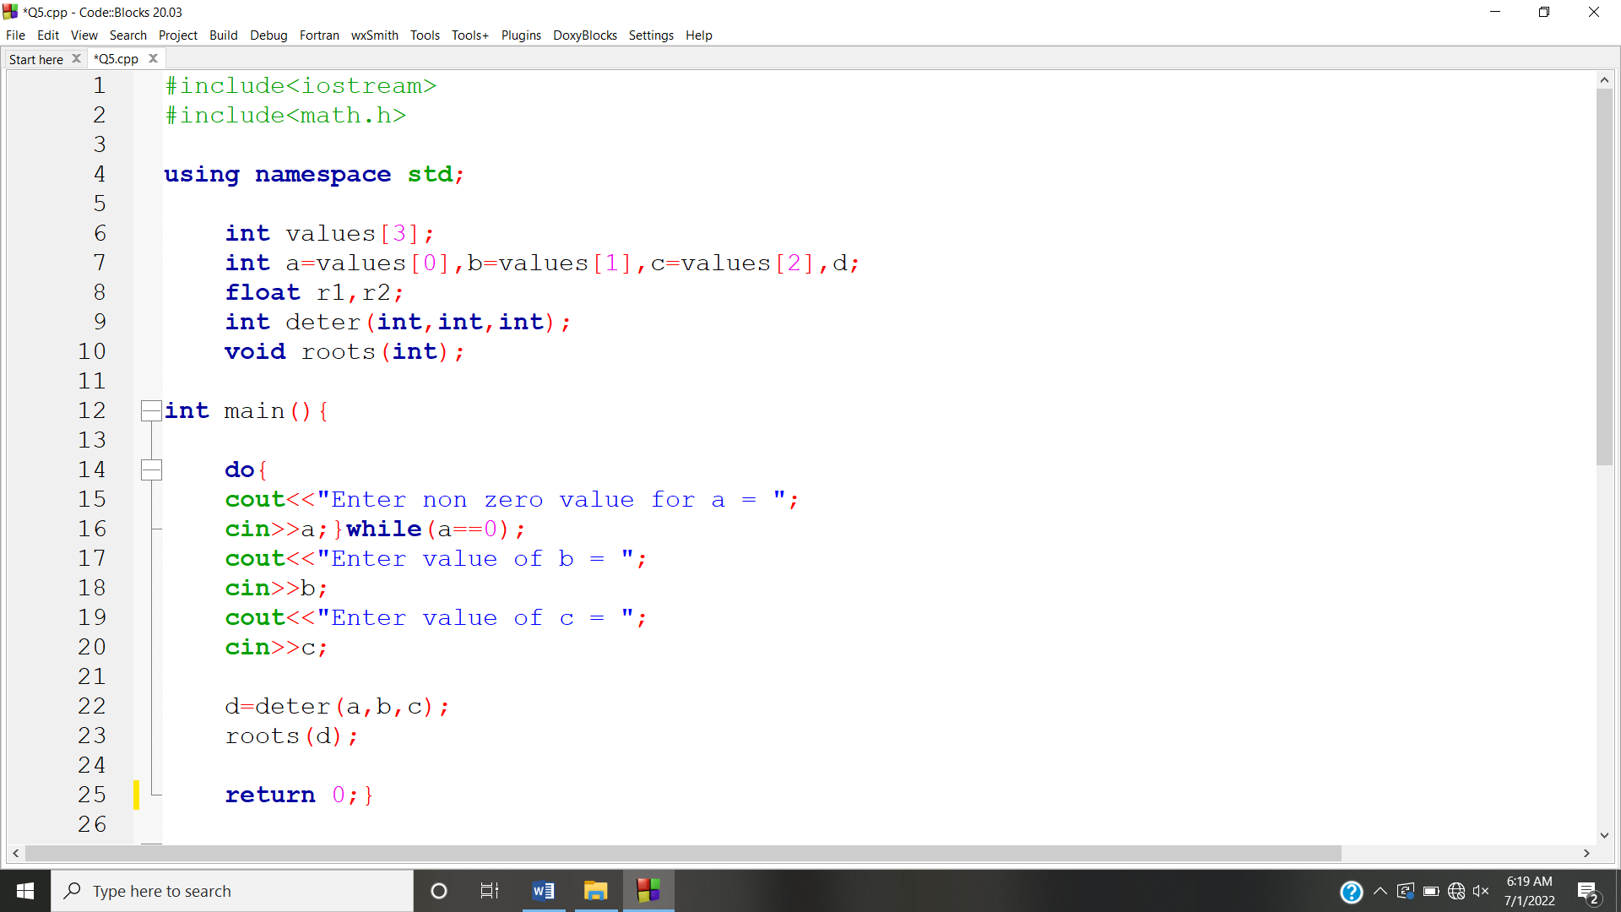

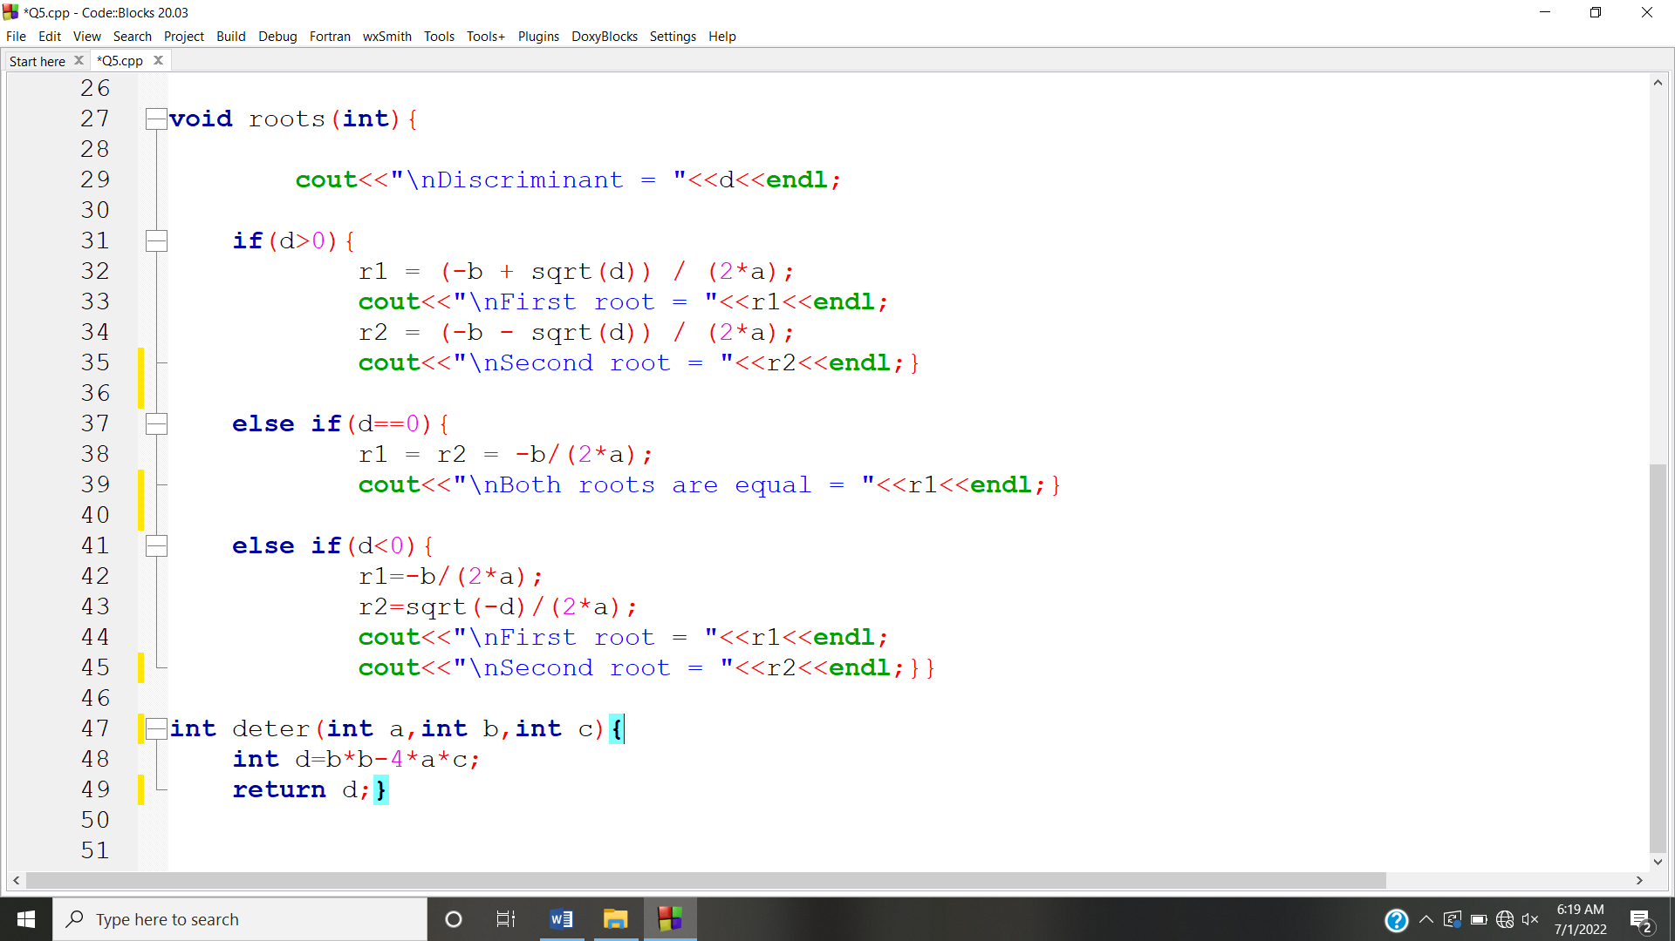

**OUTPUT:** 